CREATE TABLE prodriges_374222.user_transac
ON CLUSTER kube_clickhouse_cluster
(
user_id_out Int64,
user_id_in Int64,
important Int64,
amount Float64,
datetime DateTime
)
ENGINE = MergeTree()
PARTITION BY toYYYYMM(datetime)
ORDER BY (user_id_out, user_id_in, amount);

CREATE TABLE prodriges_374222.distributed_user_transac
ON CLUSTER kube_clickhouse_cluster AS prodriges_374222.user_transac
ENGINE = Distributed(
kube_clickhouse_cluster,
prodriges_374222,
user_transac,
xxHash64(datetime)
);

DESCRIBE TABLE prodriges_374222. user_transac

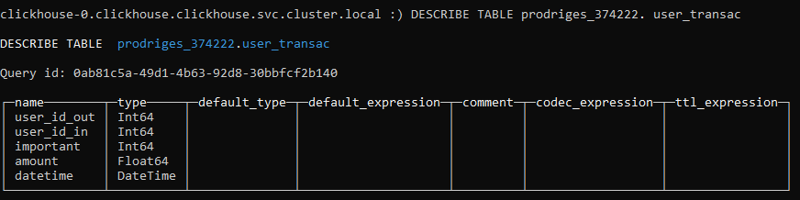

cat shared-data/clickhouse_data/transactions_12M.parquet | \
clickhouse-client --host=clickhouse-0.clickhouse.clickhouse \
--user=prodriges_374222\
--password=479Ak98oRi \
--query="INSERT INTO prodriges_374222.distributed_user_transac FORMAT Parquet"

DESCRIBE TABLE prodriges_374222.distributed_user_transac

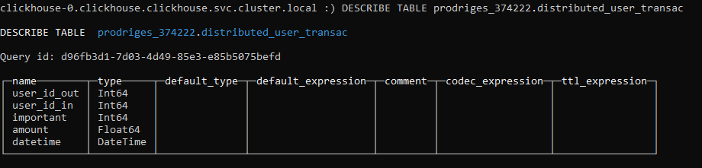

SELECT * FROM prodriges_374222.user_transac limit 10

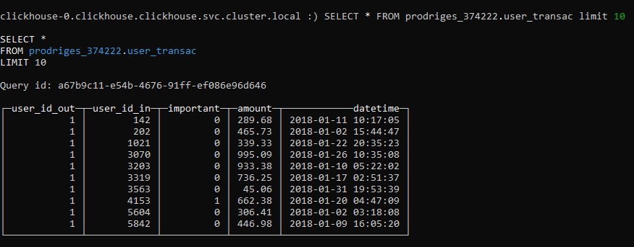

CREATE MATERIALIZED VIEW prodriges_374222.month_average_amount
ON CLUSTER kube_clickhouse_cluster
ENGINE = AggregatingMergeTree
ORDER BY (user_id, date)
POPULATE AS
WITH
suma_dentro AS (
SELECT
user_id_in AS user_id,
formatDateTime(datetime, '%Y-%m') AS date,
ROUND(AVG(amount), 2) AS avg_in
FROM prodriges_374222.distributed_user_transac
WHERE user_id_in IS NOT NULL
GROUP BY user_id, date
),
suma_fuera AS (
SELECT
user_id_out AS user_id,
formatDateTime(datetime, '%Y-%m') AS date,
ROUND(AVG(amount), 2) AS avg_out
FROM prodriges_374222.distributed_user_transac
WHERE user_id_out IS NOT NULL
GROUP BY user_id, date
)
SELECT
suma_dentro.user_id AS user_id,
suma_dentro.date,
suma_dentro.avg_in,
suma_fuera.avg_out
FROM suma_dentro
INNER JOIN suma_fuera
ON suma_dentro.user_id = suma_fuera.user_id
AND suma_dentro.date = suma_fuera.date
ORDER BY suma_dentro.user_id, si.date;

CREATE TABLE prodriges_374222.distributed_month_avg_amount
ON CLUSTER kube_clickhouse_cluster AS
prodriges_374222.month_average_amount
ENGINE = Distributed(
kube_clickhouse_cluster,
prodriges_374222,
month_average_amount
);

SELECT * FROM prodriges_374222.distributed_month_avg_amount LIMIT 15

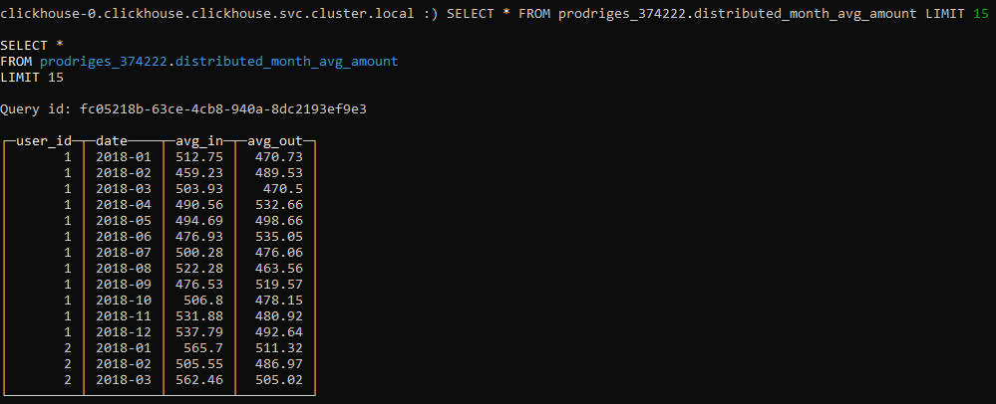

CREATE MATERIALIZED VIEW prodriges_374222.day_average_amount
ON CLUSTER kube_clickhouse_cluster
ENGINE = AggregatingMergeTree
ORDER BY (user_id, date)
POPULATE AS
WITH
suma_dentro AS (
SELECT
user_id_in AS user_id,
formatDateTime(datetime, '%d-%m-%G') AS date,
ROUND(AVG(amount), 2) AS avg_in
FROM prodriges_374222.distributed_user_transac
WHERE user_id_in IS NOT NULL
GROUP BY user_id, date
),
suma_fuera AS (
SELECT
user_id_out AS user_id,
formatDateTime(datetime, '%d-%m-%G') AS date,
ROUND(AVG(amount), 2) AS avg_out
FROM prodriges_374222.distributed_user_transac
WHERE user_id_out IS NOT NULL
GROUP BY user_id, date
)
SELECT
si.user_id AS user_id,
si.date,
si.avg_in,
so.avg_out
FROM suma_dentro AS si
INNER JOIN suma_fuera AS so
ON si.user_id = so.user_id
AND si.date = so.date
ORDER BY si.user_id, si.date;

CREATE TABLE prodriges_374222.distributed_day_avg_amount
ON CLUSTER kube_clickhouse_cluster AS
prodriges_374222.day_average_amount
ENGINE = Distributed (
kube_clickhouse_cluster,
prodriges_374222,
day_average_amount
);

SELECT * FROM prodriges_374222.distributed_day_avg_amount LIMIT 15
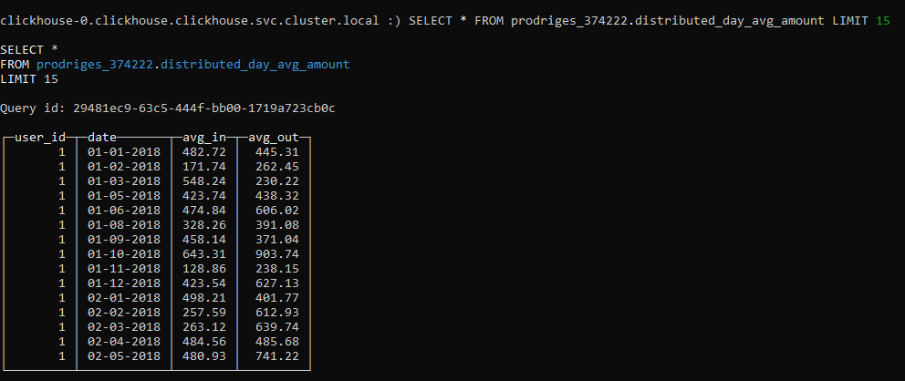

DESCRIBE prodriges_374222.distributed_month_avg_amount
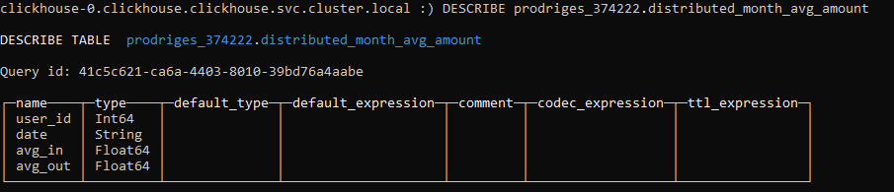
DESCRIBE prodriges_374222.distributed_day_avg_amount
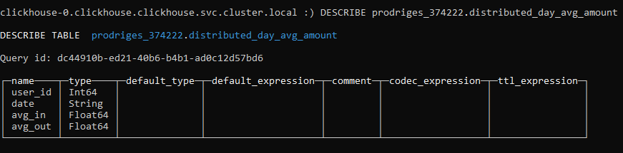

CREATE MATERIALIZED VIEW prodriges_374222.month_important_number
ON CLUSTER kube_clickhouse_cluster
ENGINE = AggregatingMergeTree
ORDER BY (user_id, date)
POPULATE AS
WITH
suma_dentro AS (
SELECT
user_id_in AS user_id,
formatDateTime(datetime, '%m-%G') AS date,
COUNT(amount) AS count_in
FROM prodriges_374222.distributed_user_transac
WHERE important = 1 AND user_id_in IS NOT NULL
GROUP BY user_id, date
),
suma_fuera AS (
SELECT
user_id_out AS user_id,
formatDateTime(datetime, '%m-%G') AS date,
COUNT(amount) AS count_out
FROM prodriges_374222.distributed_user_transac
WHERE important = 1 AND user_id_out IS NOT NULL
GROUP BY user_id, date
)
SELECT
si.user_id AS user_id,
si.date AS date,
si.count_in,
so.count_out
FROM suma_dentro AS si
INNER JOIN suma_fuera AS so
ON si.user_id = so.user_id
AND si.date = so.date
ORDER BY si.user_id, si.date;

CREATE TABLE prodriges_374222.distributed_month_important_number
ON CLUSTER kube_clickhouse_cluster AS prodriges_374222.month_important_number
ENGINE = Distributed(
kube_clickhouse_cluster,
prodriges_374222,
month_important_number
);

SELECT * FROM prodriges_374222.distributed_month_important_number LIMIT 12

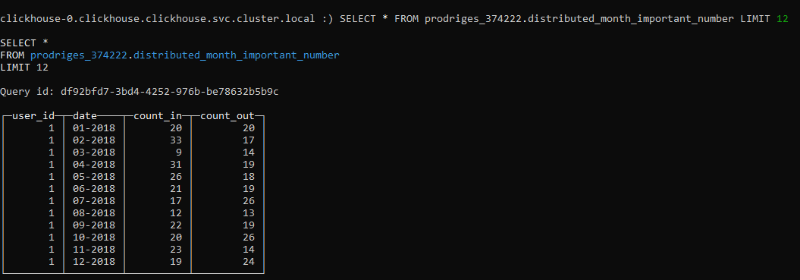

CREATE MATERIALIZED VIEW prodriges_374222.day_important_number
ON CLUSTER kube_clickhouse_cluster
ENGINE = AggregatingMergeTree
ORDER BY (user_id, date)
POPULATE AS
WITH
suma_dentro AS (
SELECT
user_id_in AS user_id,
formatDateTime(datetime, '%d-%m-%G') AS date,
COUNT(amount) AS count_in
FROM prodriges_374222.distributed_user_transac
WHERE important = 1 AND user_id_in IS NOT NULL
GROUP BY user_id, date
),
suma_fuera AS (
SELECT
user_id_out AS user_id,
formatDateTime(datetime, '%d-%m-%G') AS date,
COUNT(amount) AS count_out
FROM prodriges_374222.distributed_user_transac
WHERE important = 1 AND user_id_out IS NOT NULL
GROUP BY user_id, date
)
SELECT
si.user_id AS user_id,
si.date AS date,
si.count_in,
so.count_out
FROM suma_dentro AS si
INNER JOIN suma_fuera AS so
ON si.user_id = so.user_id
AND si.date = so.date
ORDER BY si.user_id, si.date;

CREATE TABLE prodriges_374222.distributed_day_important_number
ON CLUSTER kube_clickhouse_cluster AS prodriges_374222.day_important_number
ENGINE = Distributed(
kube_clickhouse_cluster,
prodriges_374222,
day_important_number
);

SELECT * FROM prodriges_374222.distributed_day_important_number LIMIT 15

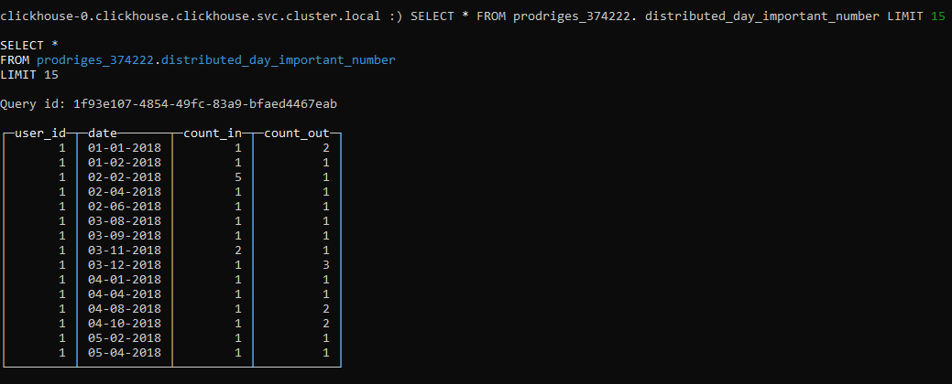

DESCRIBE prodriges_374222.distributed_month_important_number

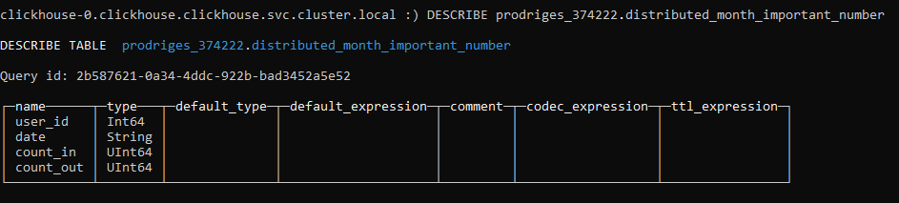
DESCRIBE prodriges_374222.distributed_day_important_number

